[Company name]  [Company address]

**Description:** We are going to install our start-up company to the new building, so we have to install the Datawarehouse in that building. Which requires some planning, investments, and proper arrangements so that we can easily and efficiently build up our Datawarehouse for the better performance and security.

The given points are explaining the floor plans, its arrangements and details shipping costs for the equipment of the required product which is ordered by the admin.

**Initial cost summery 2020**

|  |  |  |  |  |  |  |  |
| --- | --- | --- | --- | --- | --- | --- | --- |
| **Device type** | **Details** | **Item** | **Vendor** | **Qty** | **Unit Price** | | **Extended Price** |
| Hardware: | | | | | | | |
| Workstations | HP DC5100, 512MB DDR2, 40gb HD, 2.8 ghz P4, Integrated Graphics, CD-RW, GB ethernet, Optical mouse, includes Windows XP Pro | DC5100 | HP.com | 12 | $1460.76 | | $17529.12 |
| Monitor | Samsung 17-inch Sync Master 710N | RCF710NBLACK | https://legendmicro.com | 12 | $259.99 | | $3119.88 |
| Application Server | HP ProLiant DL320 G3 SCSV Server/ Dual 72.8 GB hot swappable HDs/1GB ECC DDR memory | DL320 | HP.com | 1 | 5343.30 | | $5343.30 |
| Firewall Server | HP ProLiant DL320 G3 SATA Server  Intel® Celeron ® 2.93GHz/533MHz processor, 512 MB Advanced ECC PC3200 DDR SDRAM, HP 80GB SATA 1.5Gb 7200 rpm 1’’ Hard Drive, Embedded HC7782 dual-port gigabit | DL320 | HP.com | 1 | **$**1460.00 | | $1460.00 |
| UPS 400 VA | Athena Power 400VA/200W UPS, Model UP-XP400-Retail | N82E16842116001 | https://www.newegg.com | 12 | $68.00 | | $816.00 |
| UPS 1500 VA | KIN-1500A-UPS 1500VA 2U Rack Mount | UPS-KIN-1500A-RM | Rackmount Pros | **2** | $460.00 | | $920.00 |
| Laptops | Intel ® Pentium ® 4530 (3.0 GHz, 1 MB L2 cache, 800 MHz FSB) 512MB 400 MHz Shared DDR || SD RAM (1DIMM) 80GB 5400 RPM hard drive, 17.0-inch TFT WXGA  24X DVD/CD-RW (fixed) 56K High speed modem, 10/100/1000 NIC, 12-Cell li-ion battery Touch Pad 802.11 b/g MiniPCI card, Windows XP Pro | Nx9600 | HP.com | 4 | $1880.65 | | $7522.60 |
| Inkjet Printers | HP desk jet 6122 printer/4800 ×1200 color/ 20 PPM | C8954 BA2L | Future PowerPC | 7 | $189.00 | | $1323.00 |
| Laser Printers | HP Laser Jet 4200/LAN/1200×1200 dpi6 | N82E16828104331 | Future PowerPC | 2 | $1214.00 | | $2428.00 |
| Multifunction | HP Color Laser Jet 9500 mfp/color laser, scanner, copier, fax/4 paper trays/ 512mb memory/LAN enabled | F35165 | https://www.pcnation.com | 1 | $14070 | | $14070 |
| Switch | Cisco Catalyst WS-C2970-G24T-E24 port 10/100/1000T base-T gigabit | **WS-C2970G-24T-E** | https://www.computergiants.co.il/ | 1 | $3179.00 | | $3179.00 |
| Patch Panel | TREND ware/TREND net 48-Port Cat, 6 Rack Mount Patch Panel | N82E16B31101006 | https://www.newegg.com | 1 | $96.00 | | $96.00 |
| KVM Switch | IOGear MiniView Ultra KVM Switch GCS 138-monitor/Key board/ mouse switch-8 ports | GCS 138 | https://www.compsource.com/ | 1 | $210.00 | | $210.00 |
| LCD Rackmount | 15’’ LCD Keyboard 1U Rackmount | RMD515 | https://shop.serversdirect.com/ | 1 | $1008 | | $1008 |
| Tape Drive | Certance CD72 36GB Native/uncompressed | CD72LW1U-S | https://www.computergiants.co.il/ | 1 | $1118.00 | | $1118.00 |
| Tap Media | 1PK 36/72GB DAT72 4MM TAPE CARTRIDGE | CDM72 | https://www.computergiants.co.il/ | 30 | $25 | | $750 |
| Rack | Ritual 42U PS Server Rack Enclosures | - | DSI Wholesaler | 1 | $850 | | $850 |
| Total Amount | | | | | | | $31872.9 |
| **Software:** | | | | | | | |
| Office | MS Office 2003 Pro Included with price of workstation only need 4 copies for the laptops | 269-06738-oem | Roval Discount | 4 | $295.0 | | $1180.00 |
| Server OS | RED HAT ENTERPRISE LINUX ES 3.0 | RHF0147US | Qsurance | 1 | $826.73 | | $826.73 |
| ScorPEO | 3 users |  | ScorPEO | 1 | $15000.00 | | $15000.00 |
| ScorPEO Licenses | 12 users |  | ScorPEO | 12 | $3250.00 | | 3900.00 |
| Software Total: | | | | | | | $20906.7 |
| Setup Costs: | | | | | | | |
| Data Conversion | ScorPEO 24 hours | - | - | 24 | $130.00 | | $3120.00 |
| Training | 2 Days Onsite | - | - | 2 | $1100.00 | | $2200.00 |
| Expenses | Airfare | - | - | 1 | $405.00 | | $405.00 |
| Expenses | Lodging (six nights) | - | Embassy Suites | 6 | $145.00 | | $870.00 |
| Drop Installation | Two Bubbas Installation | - | - | 32 | $75.00 | | $2400.00 |
| Total Setup Costs: | | | | | | | $8995.00 |
|  | | | | | | | |
| **Total Network Installation Costs** | | | | | | | **$61774.6** |
|  | | | | | | | |
| **Recurring Costs (Annual Estimation):** | | | | | | | |
| **Printer Cartridges:** | | | | | | | |
| Laser Toner | HP 38A black Toner cartridge for HP, Laser Jet 4200 Series-12000 pages | Q1338A | Imaging Supply Depot | 12 | $136.95 | | $1643.4 |
| Laser Toner (Magnetic) | HP Compatible 4200 MICR Toner Cartridge 12K | Q1338M | Imaging Supply Depot | 12 | $199.95 | | $2399.4 |
| Color Inkjet | HP 78-Tri-color Print cartridge | C6578DN | Future PowerPC | 14 | $44.00 | | $528.00 |
| Black Inkjet | HP 45-black-Print Cartridge | 5164A | Future PowerPC | 14 | $40.00 | | $560.00 |
| **Printer Cartridges Total:** | | | | | | | $5130.8 |
| Paper | | | | | | | |
| Checks | 1000 sheet Quanities, Copier Void which produces a series of voids if the check is copied.  Watermark feature which cannot be photocopied various color of pantographs, Mircoprinting on border,  Security banner on front, Invisible or Visible Fibers in the paper |  | Ganson Store | 10 | $11.00 | | $110.00 |
| Regular Stock | White, 500 Sheets, Color Laser Paper, 8-1/2’’ ×11’’ | 20325952 | Officemax | 24 | $11.99 | | $287.76 |
| **Total:** | | | | | | | $397.76 |
| **Miscellaneous Costs:** | | | | | | | |
| Internet Service | DSL Line from Verizon (1.54 mbs) | - | Verizon | 12 | $210.00 | | $2520.00 |
| ScorPEO Support | 15% of purchase price | - | ScorPEO | 1 | $7275.00 | | $7275.00 |
| **Miscellaneous Costs:** | | | | | | | $9795.00 |
|  | | | | | | | |
| **Total Recurring Cost:** | | | | | | **$15323.56** | |
|  | | | | | | | |
| **Total Cost for the first year:** | | | | **$77098.16** | | | |

**Floor plan:**

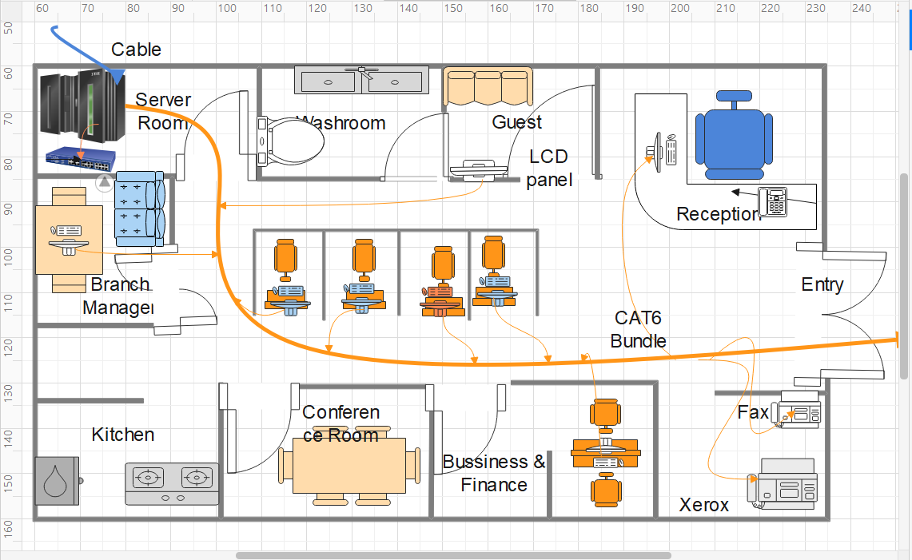

**Floor Plan design (black/white)**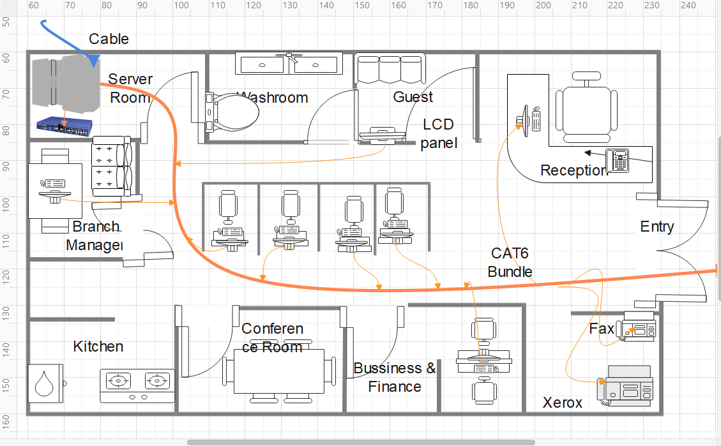

**Rack view:**

